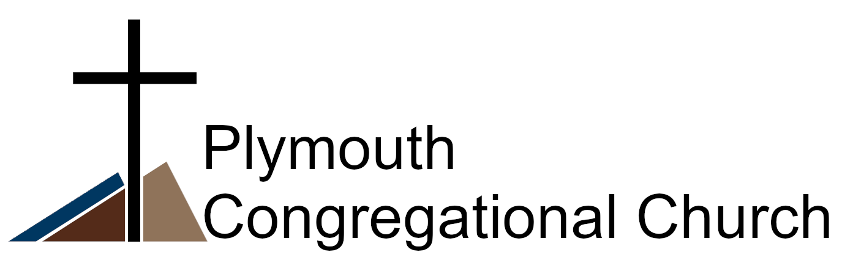

United Church of Christ
~ 2025 Annual Report ~

Table of Contents

Agenda Page 3
Annual Meeting Minutes from January 2025 Page 4
Pastor’s Report Page 7
Moderator’s Report Page 9
Vice-Moderator’s Report Page 12
Outreach and Social Justice Report Page 13
Buildings and Grounds Report Page 16
Music Director’s Report Page 17
Committee Reports Page 18
Membership Report Page 25
Treasurer’s Report Page 26
Stock Donation Options Page 28
Statement of Financial Position Page 30
Proposed 2025 Budget Page 32

Agenda
Plymouth Congregational Church Annual Meeting
January 25, 2026

1. Opening Prayer, Pastor Charles Wei
2. Review and adoption of January 2025 Annual Meeting Minutes
3. Highlights from Committee Reports
4. Presentation and Adoption of Proposed 2026 Budget
5. Election of Council Members for 2026
Slate:
Moderator: Lynn Bolin
Vice-Moderator: Open
Leadership Interns: Tommy Williams and Caryn Adolph
Treasurer/Financial Affairs Coordinator: Gail Tronstad
Secretary: Jeanne Wolf
Building and Grounds Team: Rev. Dick Weaver, Marcia Lauer, Ed Field
Mission and Outreach Coordinator: Gus Byrom

6. Announcement of Committee Appointments
Fellowship: Marcia Warner
Personnel: Rosanna Skelton, Gail Tronstad, Liz Gunderson
Pastoral Care: Amy Demaree, Lynn Bolin

7. Good of the Community
8. Closing Prayer, Pastor Charles Wei

Plymouth’s Mission is to nurture our congregation and the wider
community with acts of love and a vision of God’s image in all things.
Plymouth Congregational UCC
Annual Meeting January 26, 2025
Mary Drysdale, substituting for Secretary Jeanne Wolf
Moderator Jan Clinard called the meeting to order at 10:45, immediately following the church service with 46 in attendance. Pastor Charles Wei gave the opening prayer.
Members were asked to review the 2024 annual report minutes. Lynn Bolin moved to accept the minutes and Sunny Ray Mandeville seconded. All approved.
Members were asked to review the minutes from the special meeting held February 25, 2024 due to errors in the budget. Kathe Simons moved to accept the minutes and Sunny Ray Mandeville seconded. All approved.
Highlights of reports:
Moderator Jan Clinard:
- Expressed her joy in working with the council.
- Solar panels and new roofs were installed with a total cost of 109,947. We received $40,000 from Northwestern Energy and $18,000 from the Treacy Foundation.
- The congregation was generous in their pledges.
- Kathe Simons organized a cleaning crew, and Ed Field mowed the church grounds.
- There is an average of 48 attending church each Sunday and an average of 23 people watching the service online during the week with several watching on Sunday.
- We have many building users plus the day care.
- We are grateful that Charles followed his calling, as he mentioned in today’s sermon, and is here with us.
- We are also very appreciative of Steve Michelson and his music. The church will greatly miss Nancy’s music and her joyful presence.
- We thank Alane Dallas for keeping the office running smoothly.
Vice Moderator Lynn Bolin:
- The personnel committee did reviews of Pastor Charles, Alane Dallas and Steve and Nancy Michelson. No new hires.
Pastor Charles:
- Participated in the Helena Walk to Emmaus.
- Serves as secretary for the Helena Interfaith Climate Advocates.
- Is part of the Montana Northern Wyoming Conference Green Team.
- Helped achieve designation of the North 40 as a Certified Wildlife Habitat.
- Served as Chaplain at Mimanagish Summer Camp.
- Displayed the travelling portrait gallery of our unsheltered neighbors at the Conference Annual Meeting in Billings. Sunny Rae Mandeville and Lucinda Shelden were our delegates.
- Started a weekly Bible study group with 8-12 participants attending every Tuesday.
Gus Byrom, Outreach and Social Justice, reviewed the following work:
- Homeless Survey
- Crock Pot Ministry
- East Wall Art Exhibits
- United Way Support
- Meat to God’s Love (to honor Dave Donaldson’s ministry)
- Table Tennis Tournament to assist Afghan refugees and families from the Congo
- Just Coffee
- Partnership with Big Sky UU for a sandwich ministry
- Two $500 grants from Town Pump for Neighbors in Need
- Mission envelopes for the needy
Terry Tatchell, Building and Grounds:
- Recognized Jan Clinard for her expertise, grant writing and hard work as Moderator.
- Thanked Kathe Simons, Ed Field, Jean Goetz, Marcia Lauer, and Scott
Thompson for their work around the church to help with the budget.
- Highlighted solar panels, new roofing and new windows in the day care.
Projects for the new year:
- Fixing the soffits----the birds continue to make their nests in the vents.
- New sign on Winne.
- Carpeting the altar steps.
- Installing new niches in the Columbarium.
Jan Clinard mentioned the report from Women’s Fellowship, which continues to meet September to June on the 2nd Tuesday for interesting topics and fellowship. Lunch, generally, is monthly at the Overland Express on the 4th Tuesday. Susan Butler led a sleeping bag drive to purchase over 100 sleeping bags.
Chuck Butler submitted a report for the Stewardship Drive, which he led. We received 58 pledge cards totaling $145,960---a new high.
Photos of members who passed in 2024, Evelyn Nelson, Margy Kohl, Ed Canty and Jim Powell are printed in the Annual Report. Condolences were offered to the Michelson Family on the loss of Nancy this January.
Gail Tronstad, Treasurer, recognized highlights of the year:
- Generous member pledges.
- Money from Northwestern Energy and the Treacy Foundation for solar panels.
- Kathe Simons (cleaning crew) saving $6,100 and Ed Field (lawn mowing) saving $2,400.
- Alane Dallas’ budget consciousness in the office.
- The north sanctuary ceiling insulation (repaired by Don Harriott and Terry Tatchell) solar panels and new windows in the day care.
She acknowledged Skeeter and Marcia Warner for their work on cleaning and waxing the Fellowship Hall floor. Gail thanked Don Harriott, Al Simons, Lynn Bolin, Jan Clinard and Alane Dallas for their help in developing the budget.
Gail presented and summarized the Proposed 2025 Budget and the Statement of Financial Position on December 31, 2024. A motion was made to adopt the budget as presented. Don Harriott moved to adopt and Al Simons seconded. All approved.
Moderator Jan Clinard asked if anyone would like to be on the council. No response so a motion was made to retain the council officers:
Jan Clinard Moderator
Terry Tatchell Buildings and Grounds Coordinator
Lynn Bolin Vice-Moderator
Gail Tronstad Treasurer/Financial Affairs Coordinator
Jeanne Wolf Secretary
Gus Byrom Mission and Outreach Coordinator
Al Simons moved to retain the council, Gail Tronstad seconded the motion. All approved.
Other business: Mary Drysdale asked if our updated fire alarm system would help reduce the church insurance cost. Gail Tronstad did not know but stated it was a good question.
Meeting was adjourned at 11:30 with a closing prayer from Pastor Charles.

Pastor’s Report for 2025
Rev. Charles Wei
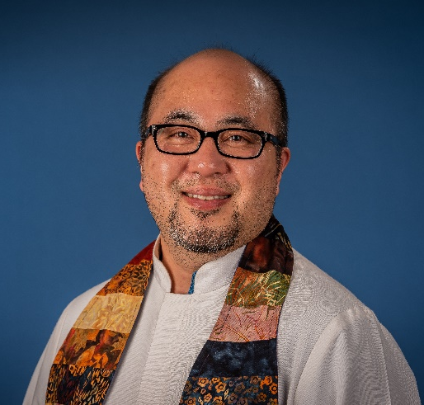
Plymouth Congregational Church, you should be proud of the work that you have done this year. There is no need to sugarcoat it, 2025 was a difficult year for me, especially with regards to the changes on the national level. This has created an atmosphere of fear, anxiety, and uncertainty, and has turned neighbor against neighbor. Frankly, it has been exhausting. It is especially frustrating when I think about what the role of the church is supposed to be: sharing God’s love with the world, building community, and taking care of those in need.
Despite all of this, we know that God is with us, and that the Holy Spirit is in our midst, moving in us powerfully to enact God’s goodness in the world. For each of the last two winters, we raised enough money to purchase 100 sleeping bags for our unsheltered neighbors, and this winter, we were able to raise much more than that, especially important this year with the questionable availability of emergency shelter. Additionally, we worked with Big Sky Unitarian Universalist Fellowship to make peanut butter and jelly sandwiches on the second and fourth Wednesdays of the month, delivering over 150 sandwiches to our unsheltered neighbors each month.
We hosted a leadership retreat for the Montana Northern Wyoming Conference in May, with pastors and lay church leaders coming from all over the conference to talk about the state of our conference, and work on ideas for revitalization. We quickly implemented one of those ideas, The One Big Neighborhood Project, designed to strengthen relationships between the congregations in our conference. We invited members of Pilgrim Congregational UCC in Bozeman for a visit in September, when members of our congregation gave them a tour of Plymouth Congregational Church, went out to lunch together at Dear Potato, and then took them sapphire mining. We all had a great day together getting to know each other, and we are excited for this project to continue throughout the conference.
I went to Kansas City, MO in July as a delegate for our conference to the 2025 General Synod of the United Church of Christ. Thousands of people from all over the country gathered to reconnect and to vote on resolutions about where the church stands on issues pertaining to human rights, social and environmental justice, and our relationship with various organizations and government bodies. These resolutions guide the work of our church and provide support for our representatives when communicating with community leaders, lawmakers, and other politicians.
We organized the Saving Us book read for the city of Helena in September, with presentations at the library, Helena Indian Alliance, Montana Wild, and in our own sanctuary. The book read and presentations brought together dozens of concerned community members to talk about the state of our climate, and steps we can take to mitigate the dangers inherent to the changes that are coming. Plymouth Congregational Church has always been at the forefront when it comes to social justice issues like this, and the people of Helena often look to us for leadership and guidance.
Throughout the year, I served as the secretary for the Helena Interfaith Climate Advocates, and at our Conference Annual Meeting in October in Missoula, I was elected to be the secretary for the conference Board of Directors. Plymouth Congregational Church will be hosting the Conference Annual Meeting in 2026, so we will have our work cut out for us!
We ended the year by accepting six new members, with more wanting to join soon, and a beautiful Advent and Christmas season. A small group of us spent a Saturday baking cookies and delivering them to our neighbors, several of whom said they had never spoken to someone from the church in all of the time that they’ve lived here.
Plymouth Congregational Church is a special place, not because of the building or its location, but because of the people who make up the congregation. It is evident that the Holy Spirit is at work among us, and I am so proud to be the minster of such a loving, hard-working, and generous congregation. Thank you for your dedication to doing God’s work and for being an example of God’s justice for the people of Helena, and beyond.
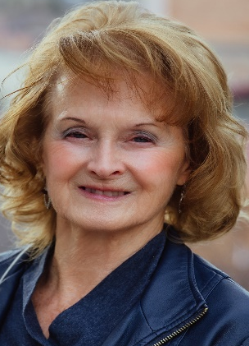
Moderator’s Report
Jan Clinard
Our Plymouth Church Council kept experienced officers
in 2025, with meetings generally on Thursday afternoons
of each month, always accompanied by tea and a new
treat, baked by Pastor Charles. Reports from Building and
Grounds, Financial Affairs, Outreach and Social Justice, and Pastoral Care describe challenges and accomplishments in more detail. Secretary Jeanne Wolf began recording meetings to ensure accuracy in our minutes. Although we do not post the minutes, they are available upon request.
We mourned the loss of our music co-director, Nancy Michelson, whose strong singing voice and seasonally-illustrated Power Points graced our services. Many of us attended her service in June, which Steve planned with the beautiful music of his Mirinesa choral group, poetry, and memories. A meal followed at their farm. We have adjusted, assisted by Lucinda Sheldon’s purchase of a laptop dedicated to the Power Points, making hymns and scripture easier to read.
With our solar panels generating electricity, we paid about $2,000 less for electricity in 2025 than in 2024. Nine months of the year, our electrical supply cost is $0. Plymouth continues to host the Helena Interfaith Climate Advocates, who carefully selected Climate Change: Let’s Talk About It as the theme of the book read for summer and fall (much like last year’s Unsheltered). Jennifer Thompson secured a series of four speakers, addressing diverse climate topics for each Wednesday in September.
The Outreach and Social Justice Committee continues to explore solutions to homelessness. With additional churches helping, we raised funds for sleeping bags, pads, and tents. We provide warm food through our crockpot ministry and make sandwiches twice each month.
Building and Grounds provide our congregation with a place for worship and fellowship, rental income, and a spacious venue for community events. New niches were added to the Columbarium and wider chancel steps were permanently built. Coordinator Terry Tatchell reminded us of the many future needs: doors, locks, windows, soffits, and elevator repair. After a December windstorm snapped off four pine trees, Don Harriot revved up his chain saw, and began clearing debris and stacking firewood—epitomizing what makes Plymouth Church members so special.
Our biggest challenge this year was filling the secretary/bookkeeper position. For nearly half the year, Gail Tronstad, Lynn Bolin, Jeanne Wolf, Liz Gunderson and I stepped in to carry out functions in the office, including bookkeeping, bulletins, ordering supplies, scheduling, website posting, and newsletter publication. We appreciated Bryan Knaff’s work and now have Kendall Larson on the job.
Bible Study continues to evoke lively discussions on Tuesday mornings, the Chime Choir delights, Mary Drysdale’s Tongue Drum helps us settle into worship, and Steve Michelson never disappoints with his musical reflections. This year, we welcomed six new members to our church family.
Please remember to watch services you miss on the Plymouth website. Select “Our Next Live Worship Service,” click on the YouTube icon, then navigate to the “Live” heading where you will see photos and the dates of each service. On the website, you can also read sermons (under the Blog heading), read Waymarks from several years, learn more about Plymouth’s mission and history, admire photos from past events, and click on links to our partners, such as the UCC and MNW Conference. Please use this resource!
Our services have been streamed by an average of 24 viewers this year, ranging from 10 to 92 per Sunday. Average in-person attendance for Sunday worship was 48.4 compared to 48.6 attendees in 2024. Lowest attendance was 32 and highest was 65. We appreciate ushers who faithfully count people in the pews and record those numbers on the clipboard in the back of the church, giving us important data to report to the UCC Conference and help the Council with planning.
At the end of my five-year term as Moderator, I will miss Council meetings filled with very special people, interesting topics, important decisions, and an unmistakable sense of God’s grace and guidance. I am grateful for the church cleaners, ground maintenance crew, musicians, scripture readers, event organizers, care givers, pledgers, and our inspirational pastor. Under new Council leadership, I will be available to contribute my experience, knowledge, and a few skills I learned as Moderator.
Blessings for the New Year.

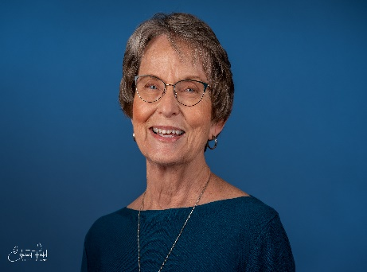
Vice Moderator’s Report
Lynn Bolin
The Vice Moderator’s position is tasked with covering Council meetings in the absence of the Moderator as well as heading up the Personnel Committee. Duties of the Vice Moderator include acting as moderator
in the absence of the Moderator and being chair of the Personnel Committee.
The Personnel Committee had a busy year as we said goodbye to our Office Coordinator Alane Dallas, who moved on to new endeavors. We hired Bryan Knaff as our office coordinator temporarily. During the transition, the Committee changed the position title to administrative assistant, to better describe the duties of the position. The Committee decided to go to Express Employment Agency to hire a new administrative assistant. After interviewing three excellent candidates the Committee selected Kendall Larson. Kendall was directly hired through Express Employment Agency on December 31, 2025.
A special thank you to the Personnel Committee (Rosana Skelton, Liz Gunderson and Gail Tronstad) for their hard work and support this past year.
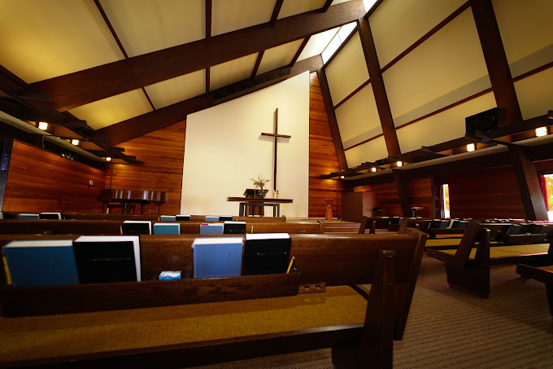

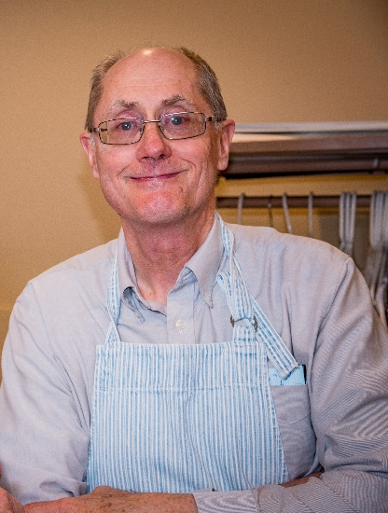
Outreach and Social Justice Report
Gus Byrom, Chair
Thanks to the wonderful membership of Plymouth and the
Helena area community, the Outreach and Social Justice
Committee of Plymouth was able to assist in many activities
throughout 2025. The members of the Committee continued
to be exceptional in their performance. The constant support
of our Plymouth Board and Pastor Charles were also
indispensable every step of the way.

Key actions undertaken in 2025 were as follows:
Crockpot Ministry
The crockpot ministry is going well, continuing to provide a warm snack at Our Place (1531 National Avenue) the third Thursday morning of each month. Our congregation has continued to respond in wonderful fashion supporting this ministry. Many deep thanks to each one of you who volunteered for this task!
Overall Housing Situation for Unsheltered in Helena
The status of the housing situation for unsheltered persons in Helena continues to be very serious. Our Outreach Committee is very active supporting the efforts of the Helena Housing Action Network. During 2025 at least one representative of our committee was present and participated at each of the Helena Housing Action Network meetings held throughout the year.
A major development has been the decision of God’s Love Shelter to limit its intake of homeless persons during winter months. This decision has prompted the United Way to seek assistance from Helena area churches to provide overnight housing.
It is hoped that members of Plymouth will be able to assist as overnight volunteers to assist those churches that are able to offer shelter to homeless persons; make a financial contribution to United Way; provide snacks at hosting churches; or help out in other ways as the Lord may guide us.
Project Warmth
Congregation member Susan Butler deserves a special “shout out” for her efforts to lead and sponsor “Project Warmth” this fall, which provided sleeping bags and tarps to Helena’s homeless. Three other local Helena churches assisted Susan in this effort: St, Peters Episcopal; St. John’s Lutheran; and Our Redeemer’s Lutheran Church. Great Work, Susan!
Climate Change – Four Week Discussion and Book Read
This major project originated with Pastor Charles and was jointly sponsored by our Outreach and Social Justice Committee and Climate Advocates, a faith-based group of leaders and members of the public. Significant to the success of this ambitious effort was grant support from the Helena Area Community Foundation which enabled us to purchase 40 copies of Saving Us: A Climate Scientist’s Case for Hope and Healing in a Divided World by Dr. Katharine Hayhoe.
Over the course of 4 weeks Wednesday meetings were held at the library, at the Helena Indian Alliance, at Montana Wild, and concluded at Plymouth. A total of 200 people attended. Topics and speakers included Curtis Grevenitz, Chief Meteorologist for KTVH News, speaking on the weather; Mike Jetty and M.L. Smoker speaking on earth care and the indigenous voice; Mark Mariano addressing bird migrations on and near the Berkley Pitt; and finally a panel discussion about faith perspectives and climate change featuring Dr. Jeannette Fregulia, Dr. Eric Mayer, and Sue Kronenberger.
Support of Helena Area Refugees
It would be fitting to add our on-going support of HARRT (Helena Area Refugee Resettlement Team). In 2024 we provided funds through a grant from the United Church of Christ ($7000) to provide after-school art and music programs taught by Katie Knight and Judy Fjell. Though the program was not continued in 2025, the lasting impact of this extraordinary effort to reach, teach, and socialize refugee children is still enormous. We are waiting to hear how or if Plymouth can lend support in other ways. Meanwhile, Rev. Dick Weaver and Donna Hathy continue to serve on the Board and offer an important link to Plymouth and our outreach efforts.
Encampment for Homeless Persons Up Orofino Gulch
Staff at the Lewis and Clark County Health Department clarified that Paul “Rad” Montee will have to prepare a plan for an encampment on his land on Orofino Gulch that meets Health Department regulations, including providing proper water supply and disposal of sanitary waste, as well as compliance with County zoning regulations. Our Committee can offer planning technical assistance to Mr. Montee as he seeks ways to assist Helena’s homeless population.
Other Assistance Throughout 2025
Over the past year, thanks to the generous financial support offered by Plymouth members, the Committee was able to offer multiple Walmart gift cards for food and other critical needs to distressed persons as well as two nights of motel lodging for a couple. With the generous assistance of a $1000 grant from the Town Pump Foundation, combined with $500 of Mission funds, Plymouth was able to finance the much-needed installation of insulation on the mobile home of a Plymouth member to avoid water line freeze up this winter.
Year End Financial Contributions
At the end of the year in December, the Committee approved remaining Committee funds to support the following local non-profit organizations:
$100 – Helena Traumatic Brain Injury Support Group
$150– Family Promise
$197- God’s Love Shelter
$150- Good Samaritan – Our Place
$200 - Helena Area Refugee Transition Team (HARTT)
$120 – Two nights – Lodging – for needy couple
Total - $917

It was an honor to serve as Committee chair during 2025. Thank you so much, Plymouth, for your on-going support!

Building and Grounds Report
Terry Tatchell
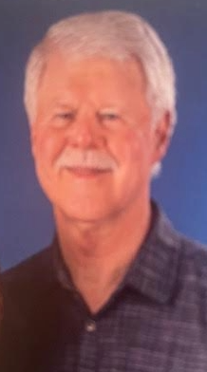
The building and grounds committee is a small, loosely organized group including Don Harriott, Ed Field, Marcia Lauer, Marcia and Skeeter Warner, and Jean Goetz. Kathe Simons and her group of volunteer cleaners keep Plymouth gleaming. I apologize to those of you I left out. It's hard to remember everyone who helps to maintain our church building.

Dick Mayer and I facilitated the installation of new columbarium niches. Dave Gruber did the installation.

Spring cleanup, June 1, had a large turnout. Much of the work was concentrated in the area north of the columbarium. A large amount of brush was removed and the lower branches of several spruce trees were cut off. Trimming shrubs around the church was performed and the flower beds were cleaned of weeds and grass.

Parking lot striping, including handicapped spaces, were done as a volunteer service by Tom Julian. Gus and Charles installed a new Wildlife Habitat sign, in the North 40 to replace the one that had been run over the previous winter.

The lights in the Founder’s Room have been converted to LED tubes, and
the main faucet in the kitchen downstairs has been replaced thanks to Don Harriott, who also repaired the leaking faucet on the hand sink as well.

In late December, Helena experienced a high wind event that blew down trees over a wide area. Plymouth was not spared. Four large trees snapped off, causing damage to one solar panel, about 15 feet of rain gutter, and a couple of bent fence rails. Don and his chainsaw went to work to cut up and remove the mess. Solar Montana replaced the damaged panel.

The altar steps have been widened to provide a safer experience for choir members. Finstads will be installing the carpeting in January.

- Projects we need to complete as funding becomes available:
- Soffit vent replacements
- Repair or replace south entry step
- Elevator repair
- Lead paint testing downstairs
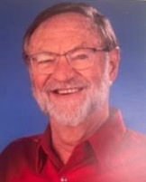
Music Director’s Report
Dr. Steve Michelson

The 2025 Church year brought with it a continuation of rehearsals by our new hand chime choir, as well as the Plymouth Choir. Both choirs made significant contributions to our worship services, September through June.
The chime choir and chime quartet have been a welcome addition to the music program here at Plymouth. Kathe and Al Simons purchased a three-octave set of Malmark hand chimes (arguably the finest chimes in the world) for our church. Their weekly progress has been very evident, as they move to more difficult and challenging music. Kathe is patient, encouraging, and kind, using positive reinforcement to help the less experienced members make progress. She accepts them where they are musically but also pushes them to greater musical understanding and skill. We are truly blessed to have her skill and knowledge as a significant part of our music program.
We continued to use guest musicians from the Helena community for special music each month and for special occasions, thanks to the continued financial support and positive feedback of our members. It is apparent that our members understand and appreciate the importance of music in worship.
For Music Sunday in June, Dr. Steve Michelson, Music Director at Plymouth, provided a Pastoral Reflection entitled “Music in Our Lives: Is it Necessary? What about in Church?” His conclusion was that certainly music is not just a frill for the gifted musician, or a luxury in our lives and in society, but rather a vital necessity that brings sanity and perspective to our society and to our individual lives. Furthermore, God uses music in the Christian church to transform our lives and help us to become more loving, more forgiving, more accepting human beings.
One sad note: we lost Nancy Michelson, wife of Dr. Michelson for seven years, to ovarian cancer on January 10, 2025. Her leadership skills, musical talent, remarkable improvisational skills on the piano, energy level, positive outlook, sparkling and infectious personality, singing ability and beautiful voice were apparent to church members each week as she partnered with Steve during worship services and even played four-hand piano pieces with Steve on occasion. Her genuine care and concern for those around her were greatly missed as the year unfolded and will continue to be missed in 2026. She will be remembered by our congregation with love, affection and respect.

Committee Reports
Without the hard work of all the members of the following committees we could not have accomplished so much in 2024.
North 40 Committee
Members: Gus Byrom, Dick Mayer, Pastor Charles
A new sign on Winne Street will be erected in 2026, with new posts and repairs to the rock base.
Pastoral Care Committee
Chair: Linda Burns
The Pastoral Care Committee members, Lucinda Sheldon. Kathleen Culver, Amy Demaree, Lynn Bolin and Linda Burns, continued to meet at least quarterly with Pastor Charles Wei to address any concerns and updates. In the fall the Committee said goodbye to Linda Burns with her move to Utah, and Amy Demaree accepted the Committee Chair position. The Committee continued to visit seven to eight members of Plymouth’s family who can’t get to Church. We took treats during visits on holidays, including tins of homemade cookies at Christmas.
Membership Committee
Kathe Simons and Mary Drysdale
A membership committee came together this past fall. In November, invitations were extended to a number of folks who had been attending Plymouth. We held a Prospective Members' class and the following Sunday, we welcomed a great group of new members to our church. The bulletin board in the Fireside Room displayed photos of our new members. Plans are underway for at least two more cycles of inviting new members to our congregation in 2027. The committee recommends wearing your nametags regularly, and welcoming any visitors you see during worship.
Worship Committee
Chair: Rev. Charles Wei
The Worship Committee met most months in 2025, navigating a lot of
ups and downs throughout the year. We lost our beloved Nancy Michelson
to cancer at the beginning of the year, one half of our music director duo.
She was so dedicated to our congregation, and went above and beyond
what was expected of her. It was a struggle to figure out how to continue
leading worship without her, and there are times even a year later when we
feel her absence.

2025 was filled with beautiful worship, from Lent and Easter to Advent
and Christmas. We once again created a contemplative space for Ash
Wednesday where we offered ashes for those who wanted that. We also
held special services for Earth Sunday, Palm Sunday, Good Friday, Easter,
Holy Humor, and our annual Breakfast at the Lake.

The chime choir, led by Kathe Simons, performed several times, and
our music director, Dr. Steve Michelson, brought in many different local
musicians for special music.

We experimented with utilizing a worship leader from the congregation whenever Pastor Charles was away, and that seemed to work well. We’ve added section headers to the worship guide to help the congregation understand the different elements of worship, and rearranged some parts of the service to make things go more smoothly. Plymouth organized another city-wide book read and educational presentations, this time related to climate change, and we had four worship services with corresponding themes for those weeks.

Our wonderful Carol McKerrow completed her final year as the
liturgical artist, a role in which she has served for over 50 years. Her faithful
attention to the altar has brought beauty and joy to the sanctuary, and we
will miss her thoughtful touch and her eye for details. Pam Rolfes has taken
up the mantle of liturgical art coordinator, and we look forward to working
with her in the years to come.

Cleaning Crew
Coordinator: Kathe Simons
What a joy to continue to organize and facilitate the weekly Cleaning Crew this past year! It's worked well to post a tentative schedule prior to each new month; this allows folks to check the schedule on a Sunday and to let me know if their scheduled time will work. Our church continues to be cleaned beautifully each week and I'm so appreciative of all of those who have helped. We're coming up on our second anniversary of this incredible team and we have saved the church thousands of dollars in the past two years. Thank you, Cleaners!
A few members have had to step back from cleaning and we do need some new volunteers for 2026. Please be in touch with me at kathe@simonshome.org, 406-860-4539, or see me on a Sunday to let me know you'd like to join this amazing team.
Sabbatical Committee
As with most Letters of Call for pastors in the United Church of Christ, Plymouth’s letter grants three months of sabbatical leave after five years of regular service. Sabbatical leave is “for a program of spiritual and intellectual refreshment,” with “goals and reporting jointly determined” by the pastor and the church. The Letter of Call also grants one week of study leave each year, with “goals jointly agreed upon” by the pastor and the church.
The UCC’s publication A Sure Foundation: Resources for the relationship between Pastors and Congregations, explains that “a sabbatical: 1) encourages longer pastorates; 2) refocuses ministry; 3) contributes to a pastor’s spiritual growth; 4) prevents burnout; 5) establishes new patterns for work and self-care; and 6) promotes congregational self-sufficiency” (p 36).
In consultation with Rev. Dr. Tony Clark, Conference Minister, the Council formed a Sabbatical Committee to assist in planning for sabbatical leave, which Pastor Charles wishes to take in 2027. On December 10, Gus Byrom, Lynn Bolin, and Jan Clinard met with Pastor Charles to explore options and suggested using study leave for sabbatical planning. Pastor Charles may appoint two other members to the committee.
With a robust plan for the spiritual and intellectual development of the pastor and meaningful fellowship and growth for the congregation, we may be able to secure a Lilly Endowment Clergy Renewal Program grant. This grant program supports “Christian congregations by providing an opportunity for pastors to step away briefly from the demands of daily parish life and discover what will make their hearts sing through well-planned purposeful activities. Renewal leaves are not vacation; rather they allow for times of intentional exploration, reflection, and regaining enthusiasm and creativity for ministry.” The grant application is due March 18, with awards of up to $60,000 to pay for seminars, classes, travel, retreats, etc. for the pastor, as well as resources for the growth and renewal of the congregation.
This year in 2026, Pastor Charles may take a few weeks of study leave for sabbatical planning. Our Sabbatical Committee will ask Plymouth members to help plan how our congregation can most effectively use the three months of sabbatical for Plymouth’s own renewal and invigoration. Your support and prayers for Pastor Charles as he plans his sabbatical and for the committee’s work will be appreciated.

Women’s Fellowship Group
Marcia Warner
The ladies of our church have been busy all year carrying out true fellowship, both in our meetings, our church, our community and around the world. Here are a few highlights:
Marcia Lauer introduced us to her friend Ann Lauer who has been working with a group of women in Africa. When Ann was on safari to see the gorillas, she met women in the village who were making quilts. Ann works for a large fabric distributor, so she helped them get supplies to carry on their work of helping the education of the local children. The students pay for tuition, uniforms and supplies, which the local women help with. The children must work in the fields and then must do their homework after dark. This made it necessary to purchase solar panels so homes had light after dark. Women’s Fellowship donated $300 towards solar panels to help this project on the other side of the world.
Women’s Fellowship also cleaned out our cupboards downstairs. Since we aren’t needing so many “things” to do “Let’s Talk About It,” we sold tablecloths, napkins, placemats, etc. to our church members and what didn’t sell was taken to Good Will, Fort Harrison and the Good Samaritan thrift store. The cupboards are cleaner and we earned some money to be used for future projects.
In November we had a lovely tea arranged by Jennifer Thompson and Susan Butler with beautiful china and the silver serving pieces from Ellie Terrell’s estate.
The latest contribution from Women’s Fellowship has been the four tall tables in the Fireside Room. It was necessary to add some space to set your coffee and cookies while we all catch up with each other after worship.
The coming year is already filling up with events, so keep watching for what the women will be doing next!
Nativi-tea event
Plymouth had another successful public outreach event with our Nativi-“tea” on December 14. It all started with Peggy Coggeshall volunteering her collection of 37 nativity scenes for viewing at Plymouth. We had a few more sets that we have used for several years at church. The idea expanded to others who had a set they could add to the display. It grew to 76 nativity displays that everyone enjoyed who shared in the event.
We had around 25 public attendees – who all wanted the event next year – and 40 or so Plymouth members who were just as impressed with the wide variety of designs depicting Jesus’ birth. Many hands set up the display the day before the event. Kathe Simons headed up the publicity, Marcia Warner helped with basic set-up and Rosana Skelton made sure we had tasty cookies and refreshments for our participants and guests.
It may be an annual event that will expand each year. Keep it in mind when you bring out your decorations for next year. Can we grow to 100 displays?
Report from the Nominating Committee
Moderator Jan Clinard appointed Jennifer Thompson, Dick Weaver and Jeanne Wolf to serve on a Nominating Committee. The three members met several times between late October and late December. They were tasked to nominate individuals to fill the Vice-Moderator and Building and Grounds positions for the church Council. (Jan Clinard, Moderator for five years, can no longer serve on the Council. After two years Terry Tatchell resigned his post on the Council but will continue to serve on the Buildings and Grounds Committee). Currently serving as Vice-Moderator, Lynn Bolin will assume the duties of Moderator. All other Council Members will continue their service.
After much consideration and valuable conversations with esteemed candidates, we are unable to nominate an individual to serve as Vice-Moderator. Duties previously assigned to that position will be absorbed by other Council members, staff, or by individuals from the congregation at large. Although a disappointing outcome, we expect that in the ensuing year, individuals will reassess their willingness to serve in this capacity.
We nominate three persons to serve as Council Members on behalf of the Building and Grounds Committee. They are Marcia Lauer, Dick Weaver and Ed Field. In case of emergencies, Dick will address calls and concerns. Though all three are encouraged and welcome to be present at Council meetings, Marcia will primarily fill that role and Dick will represent the Committee when or if Marcia is not available.
The Nominating Committee suggests an additional position to the Council, described for now as “Council Interns.” Pending Congregational approval, this opportunity will be filled by one or more newer members who may have an interest and talent for church leadership, but would benefit from a year of orientation and mentoring. This individual or individuals are nominated by the Committee, and are expected to participate in all Council meetings, taking time to listen and participate in discussion and to volunteer for tasks that are of interest. We plan to assess this mentoring opportunity by the end of next year before officially considering it part of the by-laws and church structure.
Please join us in thanking all the Council Members for their service to the church this past year. We are also profoundly humbled by the vision, skill and diplomacy exhibited by our outgoing Moderator and Building and Grounds Coordinator.

Stewardship: Because of You, Our Church Changes Lives
Chuck Butler, Stewardship Chair
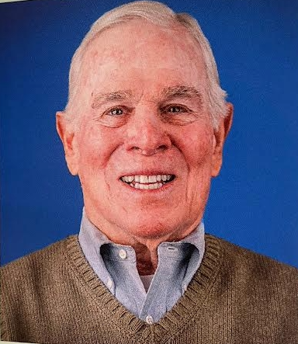
We received 61 Pledges for the 2026 Calendar Year. Those Pledges totaled $151,205. Wow! Thanks to each of you who made it possible to reach this amazing Pledge level for the operation
and sustainability of Plymouth Congregational Church.

We are truly blessed as a congregation. As Stewardship Chair, I am personally very grateful for the number of Pledges and this amazing total. And, a special thanks to Gail and Kendall for keeping track of the Pledges.
Speaking of Plymouth's generosity, thanks to everyone in our Congregation who also made donations to Project Warmth to help keep our community's homeless folks a bit warmer this winter!

New Members
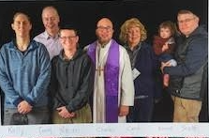
Kelly Clark-Rayl, Tommy Williams, Mariah Rayl, Pastor Charles, Carol Gleason, Scott Thompson (and Emma)
Not pictured: Caryn Adolph and Edwin Mohler
Welcome!

Passed Away
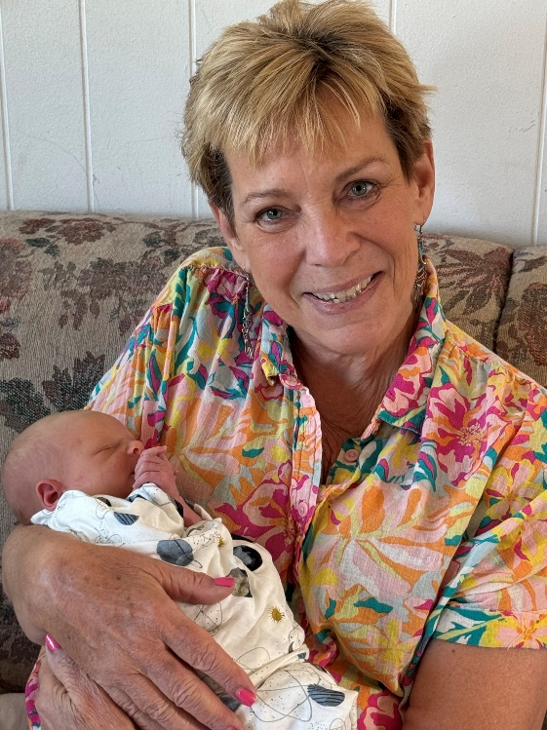
Nancy Michelson
January 10, 2025

You are deeply missed!

Treasurer’s Report
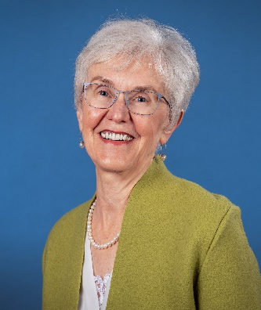
Gail Tronstad

Thank you to all who supported Plymouth Church financially, as
well as giving of time, energy and prayers in 2025.
The purpose of the Finance Committee is to nurture the church
through care and oversight of our financial resources. Some
2025 highlights include:

- $800 was given to One Great Hour of Sharing.
- $538 was given to The Christmas Fund.
- $4,670 was added to the Sabbatical/Recruitment CD.
- $12,000 was added to the Building Reserve Savings Account.
- Withdrawal of savings from our UCF investment funds for operational needs was not necessary.
- Process to make stock donations through Plymouth’s account with the United Church Fund. (Sample form included in report.)
- The water bill was significantly reduced through resetting the sprinkler system.
There are multiple individuals and groups that support the budget through sweat equity. Those we often see are Kathe Simons and the Cleaning Crew, Don Harriott, Terry Tatchell, Ed Field, Marcia Lauer, Marcia and Skeeter Warner, Jean Goetz and many others who come forward when asked. All of this is very important in the management of income vs. expense. It also supports the need to have a conducive environment for worship.
During the year the committee reviews financial reports on a quarterly basis, evaluates options when certificates mature, identifies potential sources of funding for “what if” situations, considers the needs of today while planning for the future. We make every effort to be attentive and wise in the management of your financial gifts.
The proposed 2026 budget follows. It was developed with information from the Personnel, Buildings and Grounds, Social Justice and Worship Committees. Every effort has been made to be realistic in our proposed budget while providing support for the mission of Plymouth.
Finance Committee members are Al Simons, Lynn Bolin, Jan Clinard, Don Harriott, Terry Tatchell and myself. I am grateful for their knowledge, experience and leadership as we work together.
Thank you to each and every one for the many ways you support Plymouth Church.



Stock Transfer Option

Stock Donation Options
Donating appreciated stocks can be a smart way to make charitable contributions. For example, if you purchased some stocks for $2,000 in 2015 and they are now worth $10,000, you would pay capital gains taxes on $8,000. However, if you were to donate that $10,000 stock to Plymouth (or any other nonprofit), you can claim a $10,000 charitable deduction and pay no capital gains taxes.
To make a stock donation, first take a Stock Donation Form to your stock broker. Your broker will need the information at the bottom of the form and can help you with the information needed to complete the form and send it to United Church Funds.
Plymouth will pay no fees to UCF for this transaction. Plymouth Congregational Church’s account number is #400270.
An officer of the church (Treasurer) will instruct United Church Fund on how to process the liquidated funds. The available options are:
❖ Deposit the funds into Plymouth’s UCF account (using UCF account number and allocation); or
❖ Disburse the funds into Plymouth’s bank account in Helena to be used for the church’s ongoing expenses.

The process is relatively simple for the giver and the church. If you own stocks that you hesitate to sell because of their appreciated value, please consider donating them to Plymouth Church. Their value as a charitable contribution to Plymouth will be great.
Stock donation forms are available in the church office and on the table in the Narthex.

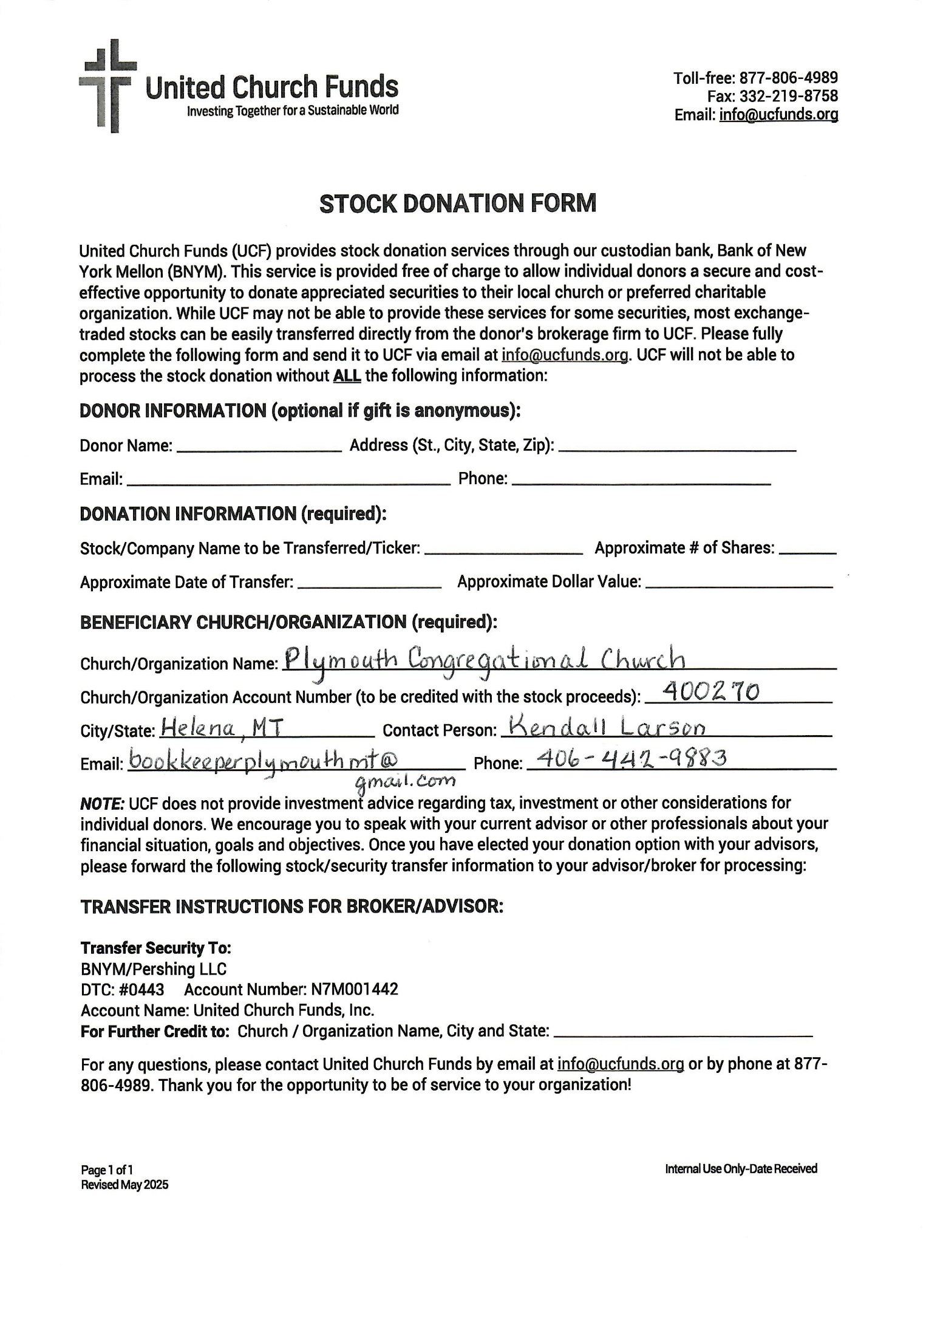
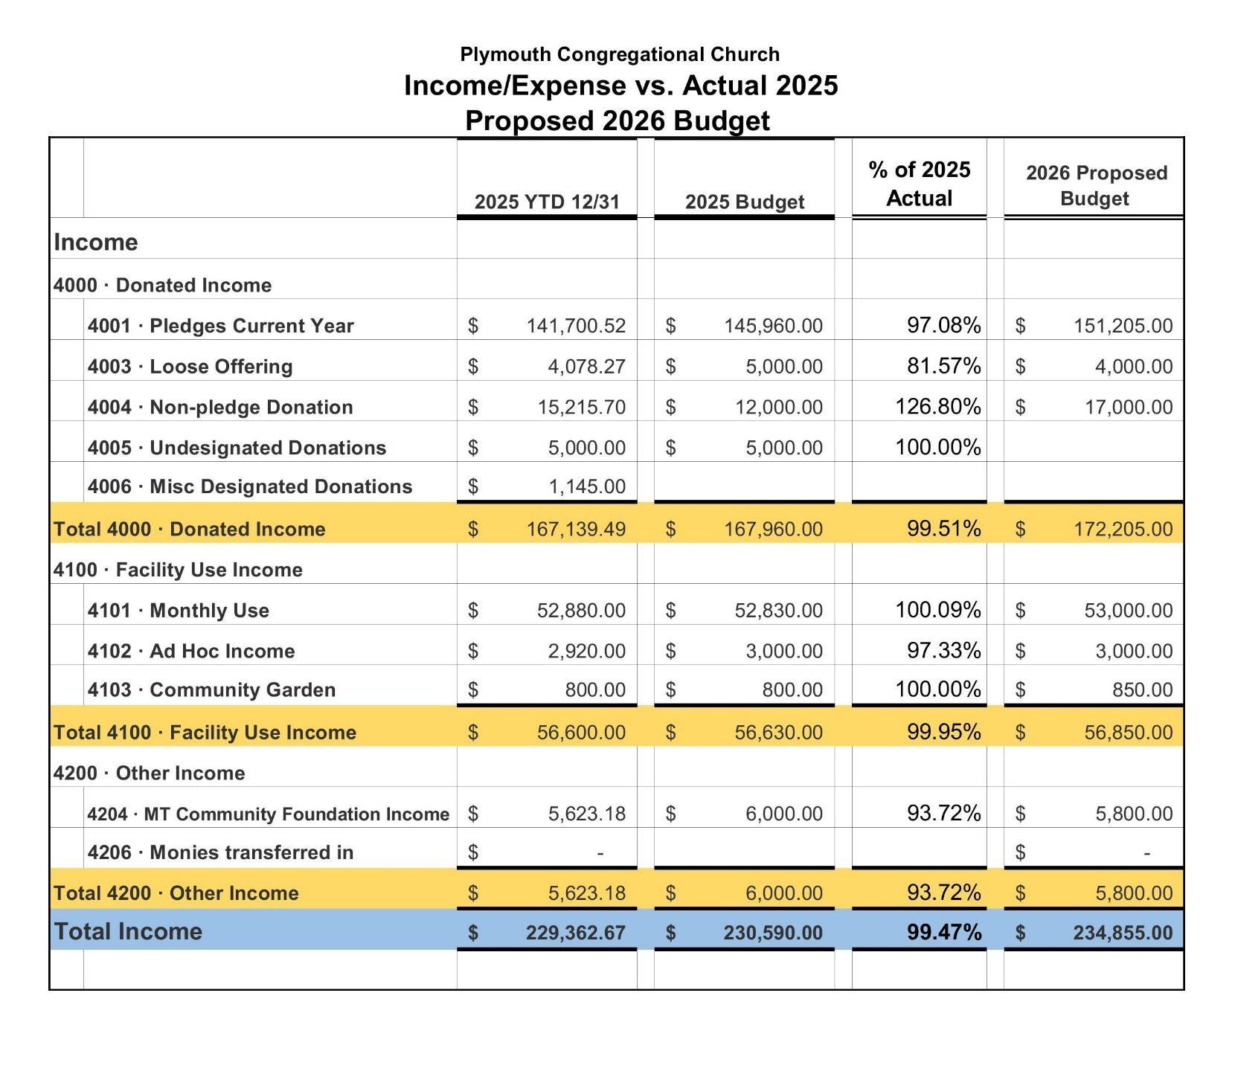
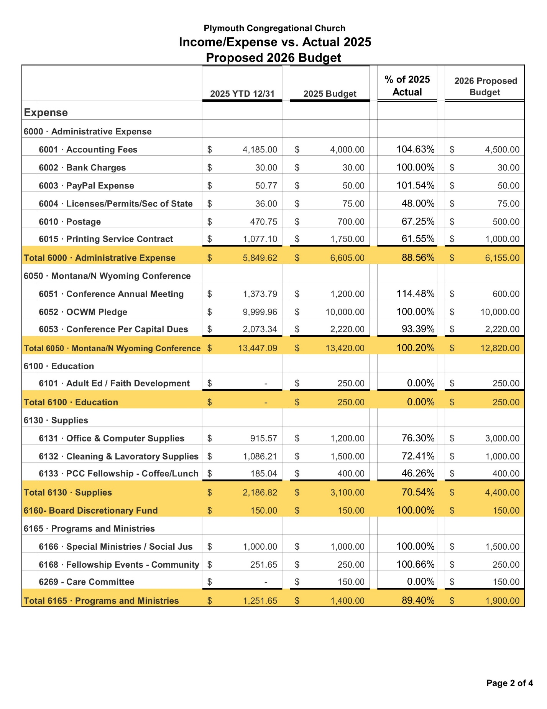

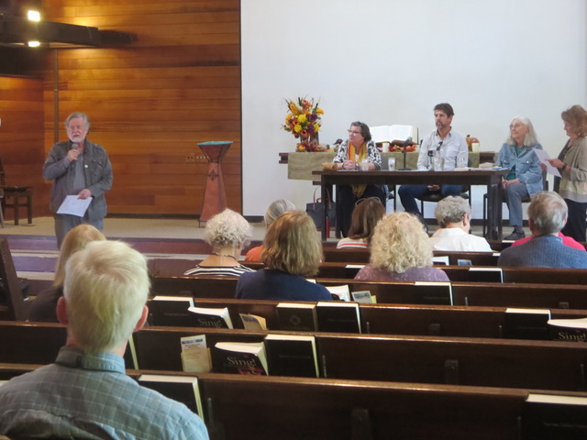
Panelists speaking at Plymouth about faith traditions and concerns for earth care.


A prayer rug exhibited at Plymouth along with other examples of Islamic, Jewish and Christian traditions.

